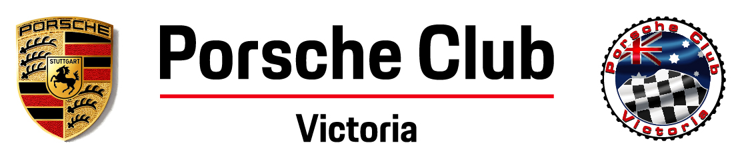
SELF SCRUTINEERING CHECKLIST
Winton Sprint - 14 February 2021
COMPETITOR NAME
VEHICLE - (REG / TYPE)
CLOTHING |  | Competitors need to wear non-flammable clothing that covers from ankle to wrist and neck. No competitor will be permitted to wear nylon or similar material.
 |  | Approved crash helmet according to Supplementary Regulations. Helmet and straps in good condition.
INTERIOR |  | Approved fire extinguisher properly mounted with metal brackets OR onboard system.
 |  | Seats firmly mounted (check mounting brackets).
 |  | Complying Harness and mountings in good condition.
 |  | Complying seatbelts in good condition.
 |  | No loose items inside vehicle or boot.
 |  | Cameras or other equipment well secured (by secondary tether).
ENGINE |  | Bonnet tie down device in position and of acceptable quality for Open, GT, M1 and M2 classes (flexible straps, cord/cable tie not permitted).
 |  | Battery (or batteries) held down securely.
 |  | Throttle return adequate and not sticky.
 |  | Brake fluid level within guidelines.
EXTERIOR |  | Brake lights operating.
 |  | Tyres - Complying, in good condition with legal or acceptable tread
 |  | Wheel bearings in good condition and correctly adjusted.
 |  | Wheel nuts correctly tightened.
 |  | Fixed tow hook in place at both ends of the vehicle.
 |  | Blue Triangle affixed above battery or battery isolation switch.
 |  | Dorian transponder fitted and operational (not required for Entrée).
 |  | Numbers correctly displayed (once at track).
SIGNED COMPETITOR
DATE

